MACH4METAL

Metalworking machinery
Transito 21,
6909 DA BABBERICH, Netherlands
Tel. + 31 (0)316 – 247123
Fax. + 31 (0)316 - 247956
info@mach4metal.com
www.mach4metal.com

Account No: 66.52.13.883
IBAN : NL33 INGB 0665 2138 83
BIC : INGBNL2A

SCHNEEBERGER ARIES ENP 2

- Make : SCHNEEBERGER Swiss
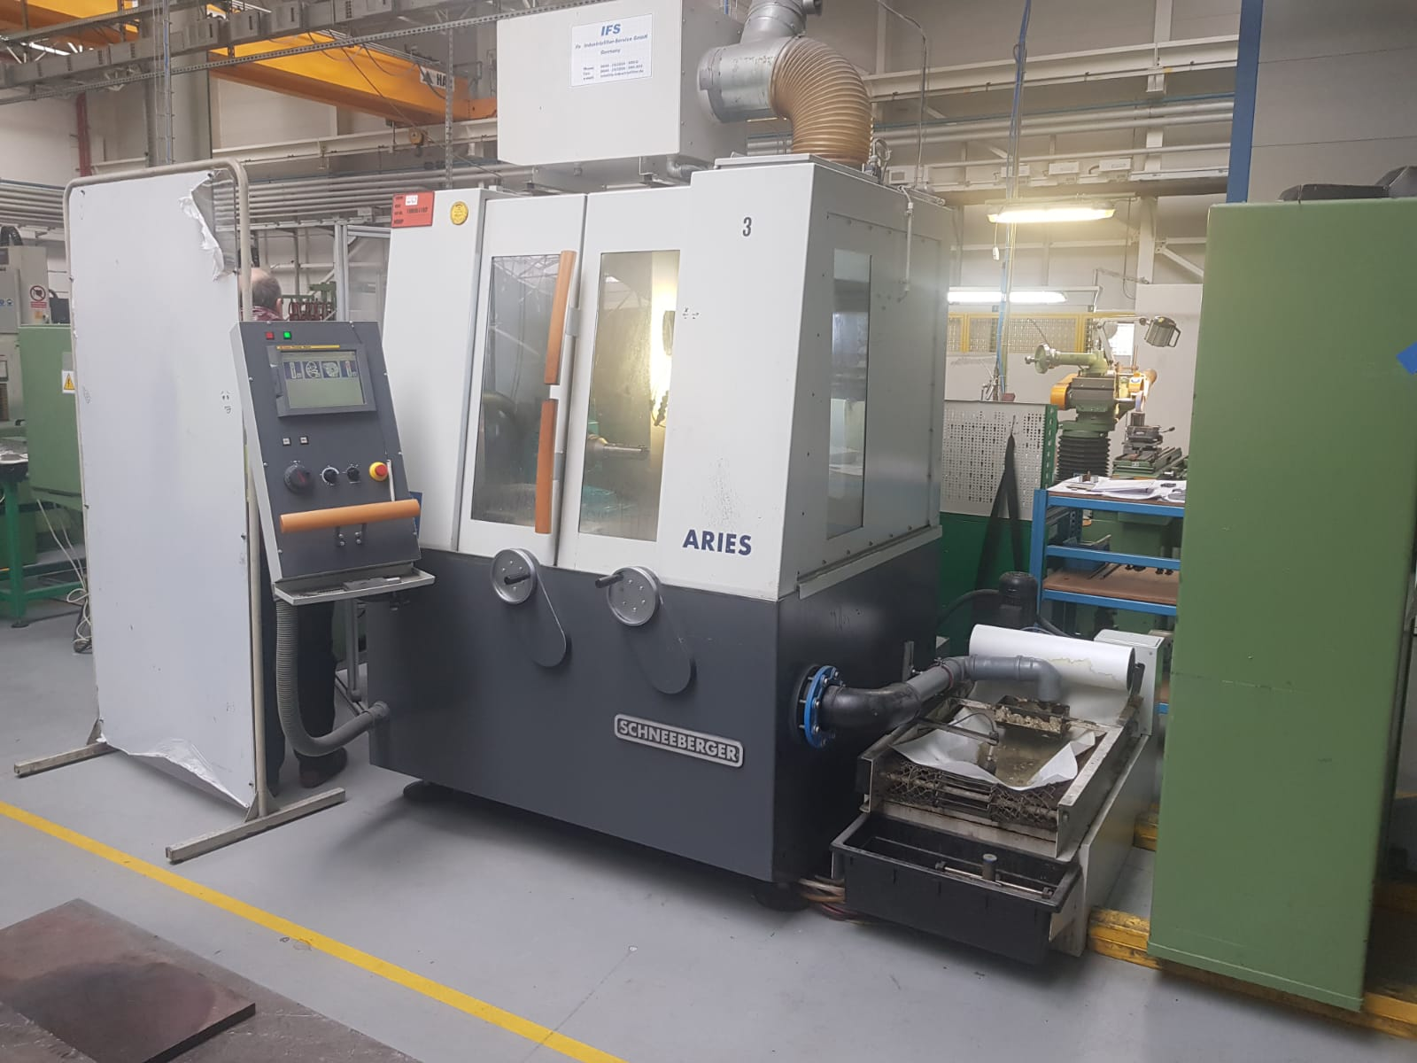
- Type : Aries ENP 2
- Mach. No : 21279
- Age : 2008

- X Travel : 400 : 0.001 mm
- Y Travel : 220 : 0.001 mm
- Z Travel : 295 : 0.001 mm
- C Travel : + 50°
- C Travel : - 270 °
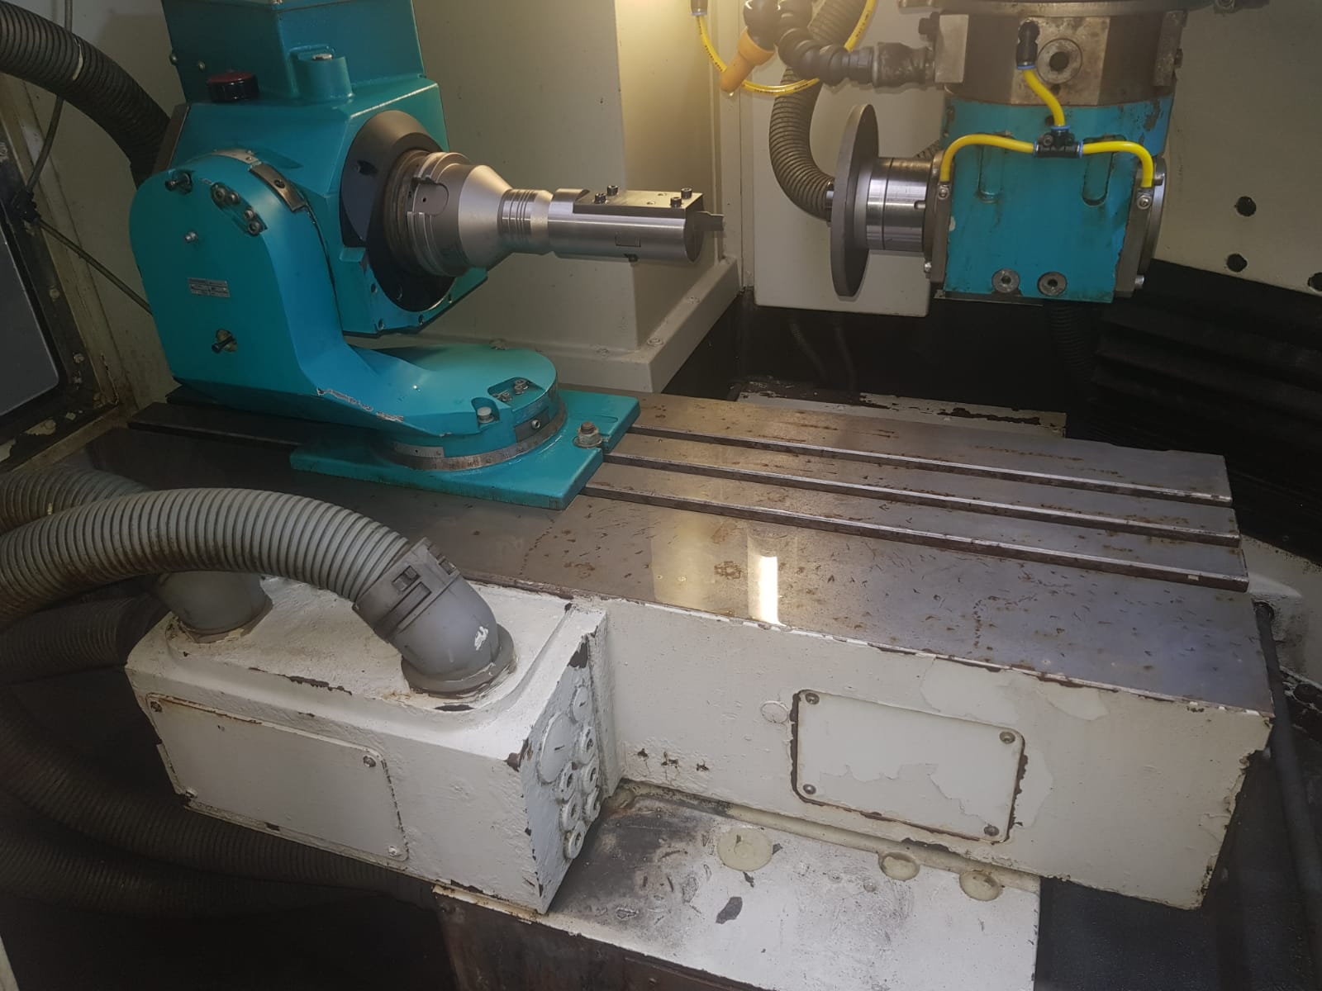
- A Axis : 360 °
- A taper : ISO 50
- Centre height : 210 mm

- Table size : 1000 x 310 mm
- Grinding wheel Ø : 50 – 250
- Grinding wheel power : 2.2 kW
- Grinding speeds : 6.000 Rpm
- Spindle taper : HSK 50

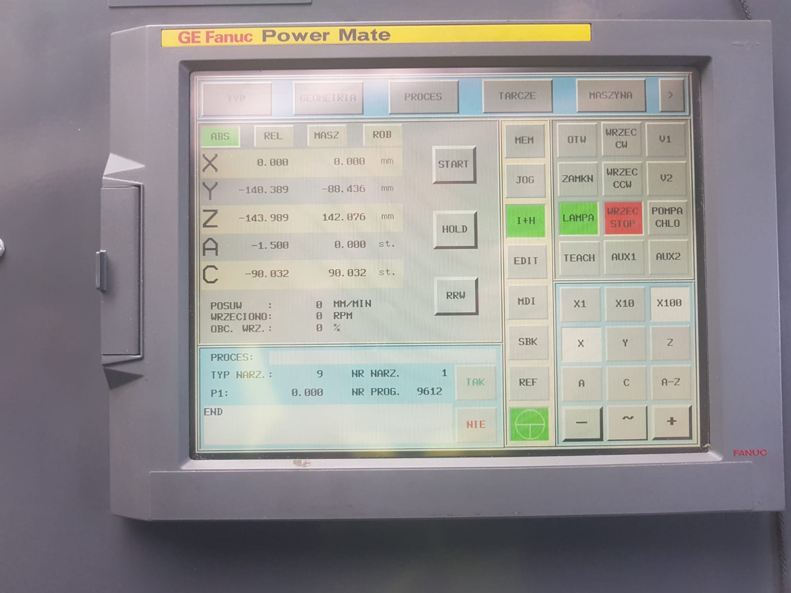
- Dimensions
- Length : 1.500
- Width : 2.077
- Height : 2.000
- Weight : 1.900

- CNC Control FANUC POWER MATE
- Run time 02.2019 4.355 H
- IFM filtration
- Filtration coolant system

Please Note: The above information has been obtained to the best of our ability and belief from, and from the manufacturers where possible. It is given in good faith, but its accuracy can not be guaranteed. Accordingly, it will not form a representation or constitute contractual terms. We advise you to check any vital details!

